# P7 - Hacking Soft Matter - Extended Materials

This guide walks you, step-by-step, through all the necessary parts required to build, program, and gather data from your home-made visible light spectrometer. It’s as comprehensive as possible, but if there’s ever a part you’re confused about, do not hesitate to email one of the lab organisers – no matter how “silly” you think the question may be.

Let’s begin!

# Your Light Spectroscopy Kit

Your kit should contain:

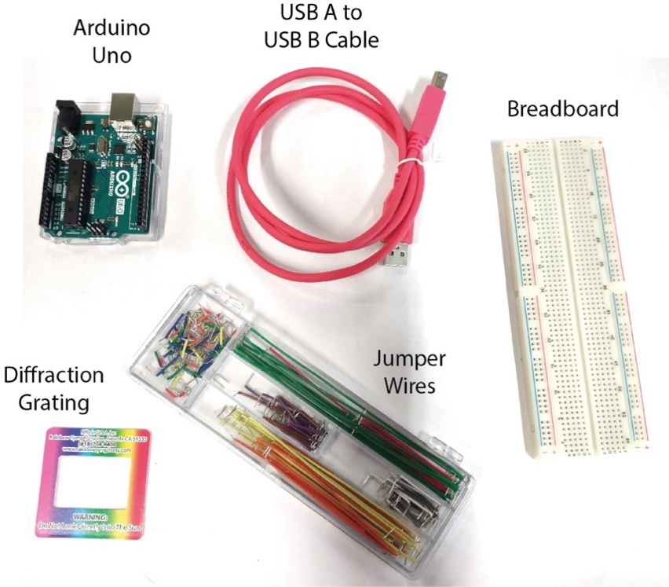

As well as 3 squares of red, blue, and green plastic filters. You’ve also been given:

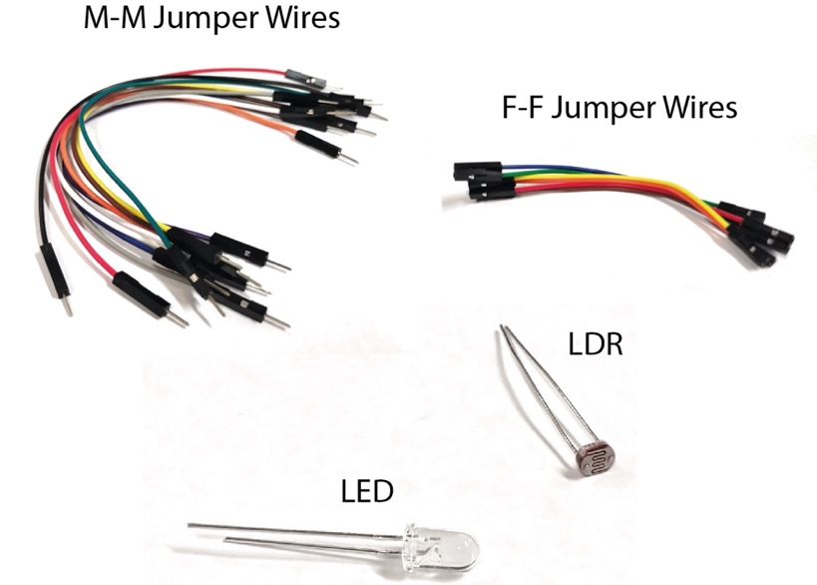

You should have also been given different resistors with the following resistances:[1]

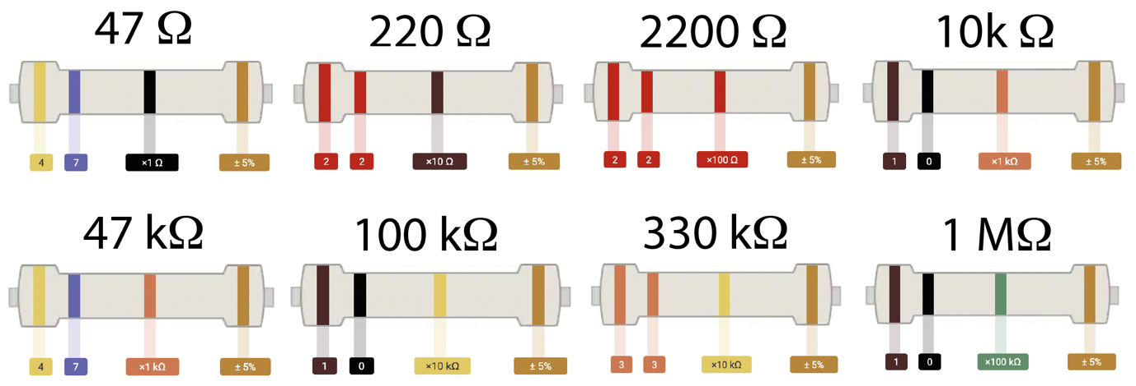

The resistors may be blue rather than yellow – but this doesn’t change how they work.[2] The resistors should be in a glass vial, along with the LED, LDR, and a 7 mm collimating lens.

There are also some 3D-printed parts for your spectrometer:

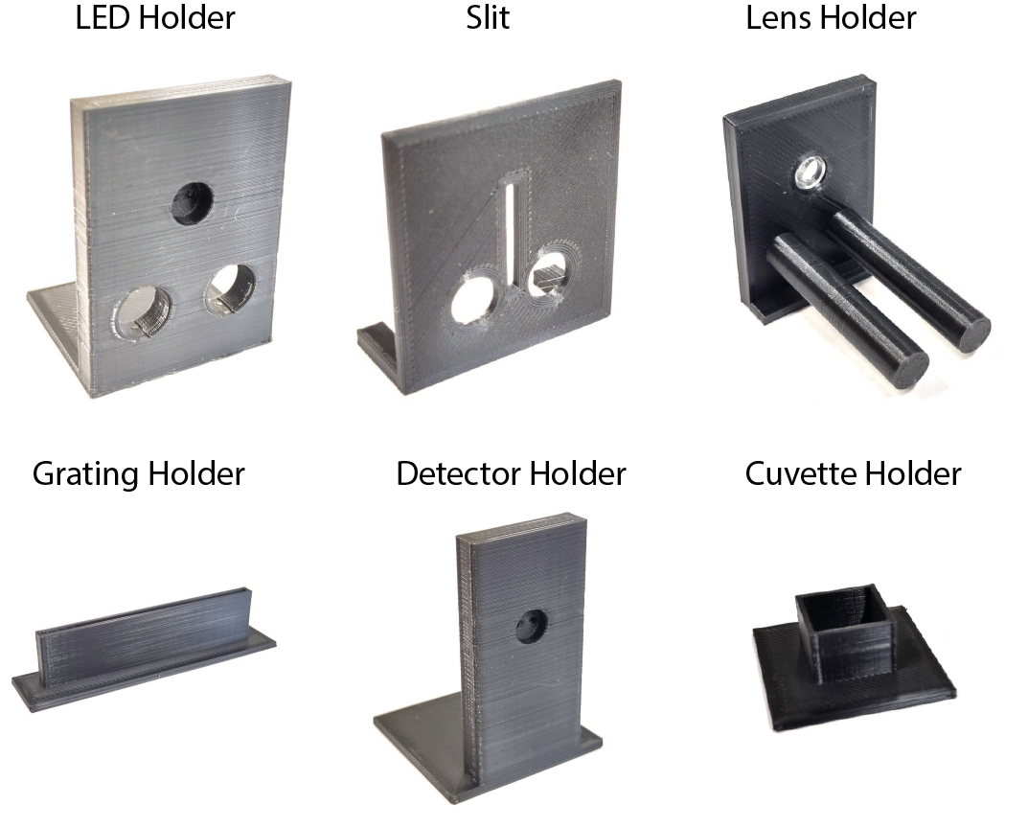

Finally, you should have been given **one A4 piece of black card, one piece of black fabric, some PVC tape, scissors, a glue stick, and permanent marker, and a 200 x 10 mm spatula.**

# Downloading Code

You’ll need to download the following bits of code from the code folder on the P7 Moodle page:

* spectrometer_minimal.ino
* data_reader_mac.ipynb **or** data_reader_windows.ipynb

Put them somewhere convenient – in this guide I’ve used a folder called ‘python’ on my desktop (‘/Users/joe/Desktop/python’) [3].

# Installing Python[4]

In this practical, you’ll use the Arduino software to control your spectrometer, and you’ll use a Python script to monitor and collect the data from your spectrometer. This module is not about coding, but rather to show you how a simple set of scripts, commercially available kit, and 3D printed parts allow you to measure the molecular properties of surfactants. If you’d like to modify the code, however – please do! Make sure you add any modified code as an appendix to your final report so you can receive credit for your efforts.

First off, let’s install Python.[5] We’re going to use a pre-packaged, freely available version of it called *anaconda*, which is widely used by the data science community. Download the Individual Edition here:

<https://www.anaconda.com/products/individual>

and follow the instructions to install it.

Now you’ll need to install some Python modules[6] to use the script. Open up a Terminal.

In a Mac, you can do this by navigating to Applications/Utilities and double-clicking on terminal. Alternatively, you can hit “Command” + “Space”, type in “terminal”, and hit enter.

In Windows, open up Anaconda Prompt.

In the terminal, type:

conda install matplotlib

and hit “Enter”. You’ll get a dialogue asking whether you want to install – hit “Enter” again.

Now type:

conda install pyserial

and repeat. Now type:

conda install pandas

And repeat. Finally, type:

conda install numpy

and repeat. Some of these are likely already installed – but it’s good to make sure!

Now let’s check everything installed right. Open “Anaconda-Navigator” and click on “Jupyter Notebook”. Your web browser should open, and you’ll get a screen that looks like this:

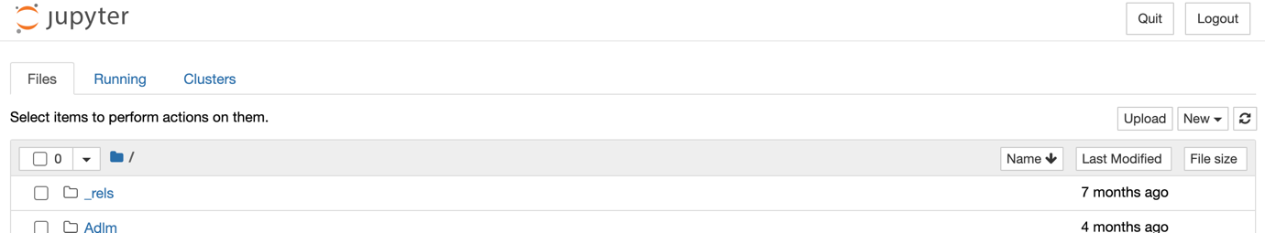

In the browser, navigate to a folder that you’d like to run your code in – I’m going to use /Users/joe/Desktop/python[7] – but you can use whatever you’d like:

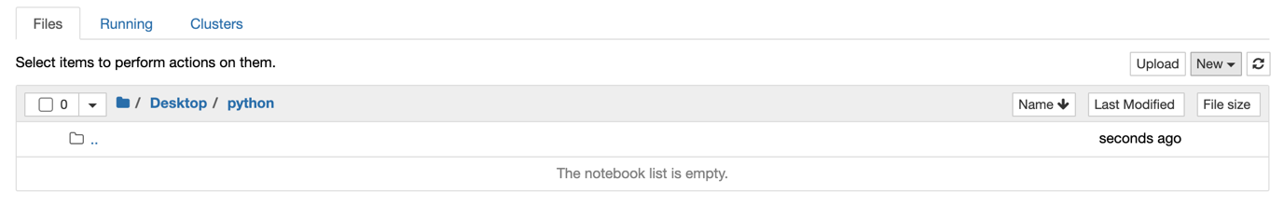

Click “New”, “Python 3” in the top-right corner.

You should get a screen that looks like this:

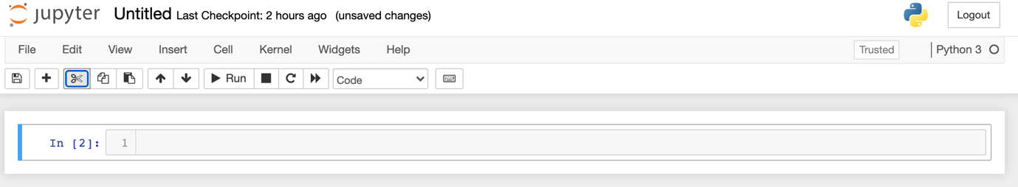

In the text box (the thing with “In [2]:” beside it in the image above), type the following:

import matplotlib

import numpy

import serial

import pandas

And hit Shift + Enter (or click “Run”) – the script should run, and a second, empty box should appear below. Just like this picture:

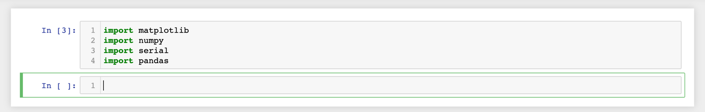

If you get an error message, you’ve not installed your modules properly! If this happens, retry the above to install the modules, and if it still doesn’t work then contact a course organiser! If that’s all worked, then congratulations! You’ve got Python up and running.[8]

Now, finally, let’s run a bit of code to test everything is working ok. Enter and run the code below in Jupyter Notebook – post the output as part of your hand-in to pre-lab 1!

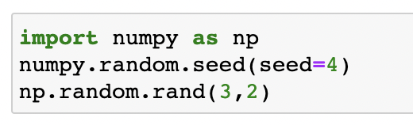

# Setting up your Arduino

First, download the Arduino software from:

<https://www.arduino.cc/en/software>

Open up the software, and check it loads OK. You should get a screen that looks like this:

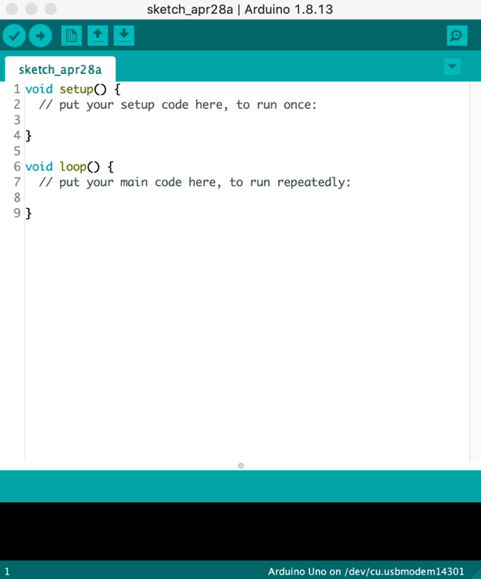

Now let’s take a look at your Arduino:

Your Arduino is the thing on the left. If you plug the USB cable into the Arduino and connect it to your computer, it should light up. The thing on the right is called a breadboard, we’ll come back to it shortly.

There are two important things to check. First, in the Arduino software, go to the menu at the top of the screen/window and click “Tools” 🡪 “Board” and check that your board is set to “Arduino Uno”, like in the screenshot below:

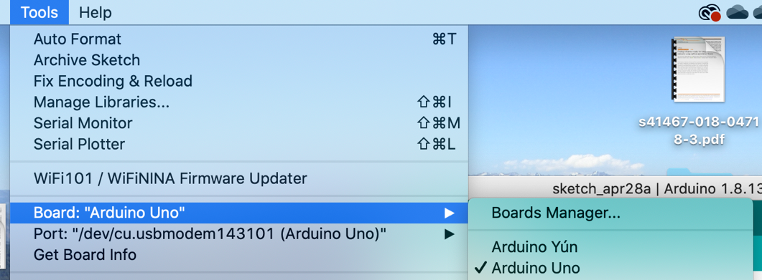

Next go to “Tools” 🡪 “Port”, and check that you’ve selected the Arduino. The window will look a bit like this:

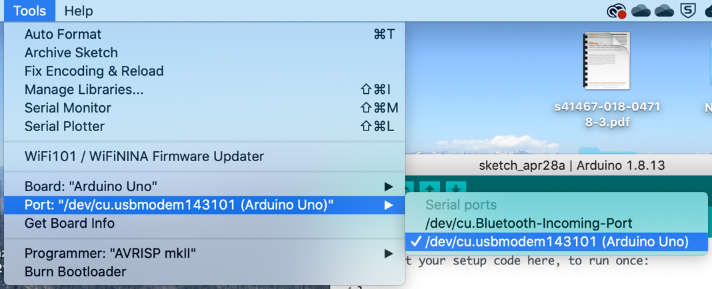

Here I’ve selected “/dev/cu.usbmodem143101 (Arduino Uno)”.[9] The text you see might be a bit different, but that doesn’t matter – what matters is that you select the option that says “(Arduino Uno)”. Again, if there’s no way of selecting the Arduino, repeat the above steps, including restarting your computer a few times, disconnecting and reconnecting the Arduino a few times, and making sure you’ve not put the Arduino on the metal case of your laptop. If you reckon you’ve done everything right, and it *still* doesn’t work, contact the course organiser!

If you’ve done all the above and it’s worked – congratulations! You’re ready to start building stuff.

# Building Your Light Source

Your spectrometer needs a light source and a detector. They look like this:

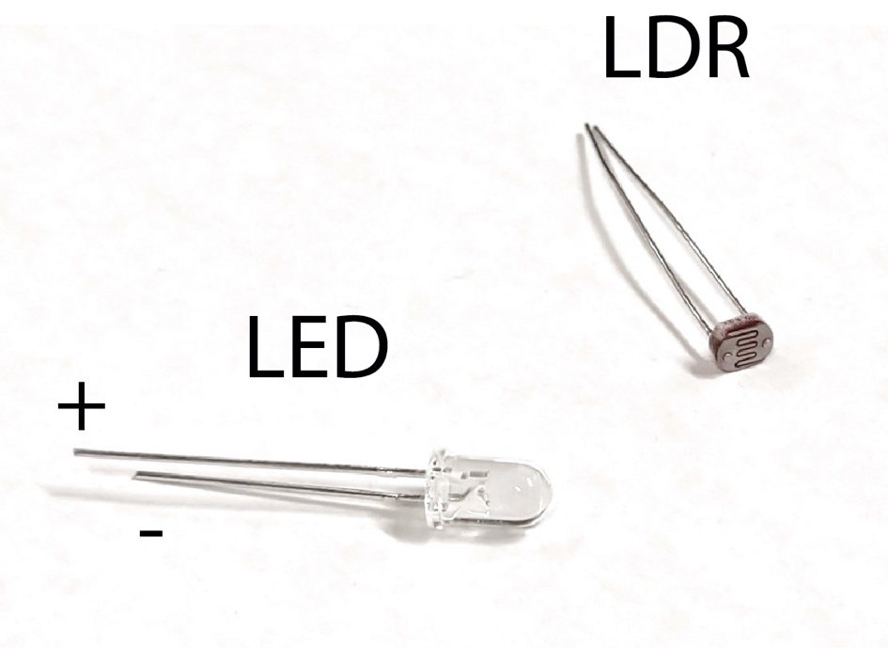

The thing on the left is a Light Emitting Diode. If you plug the longer leg to a positive voltage, and the short leg to a lower (or negative) voltage, it will light up. If you plug it in the other way round, nothing will happen![10] The thing on the right is a Light Dependent Resistor. It’s a special type of resistor whose resistance depends on the amount of light shining on it. Now let’s wire them up.

Remember the breadboard? That’s what we’re using to build our electronic circuit. I’ve drawn how current moves along it below:

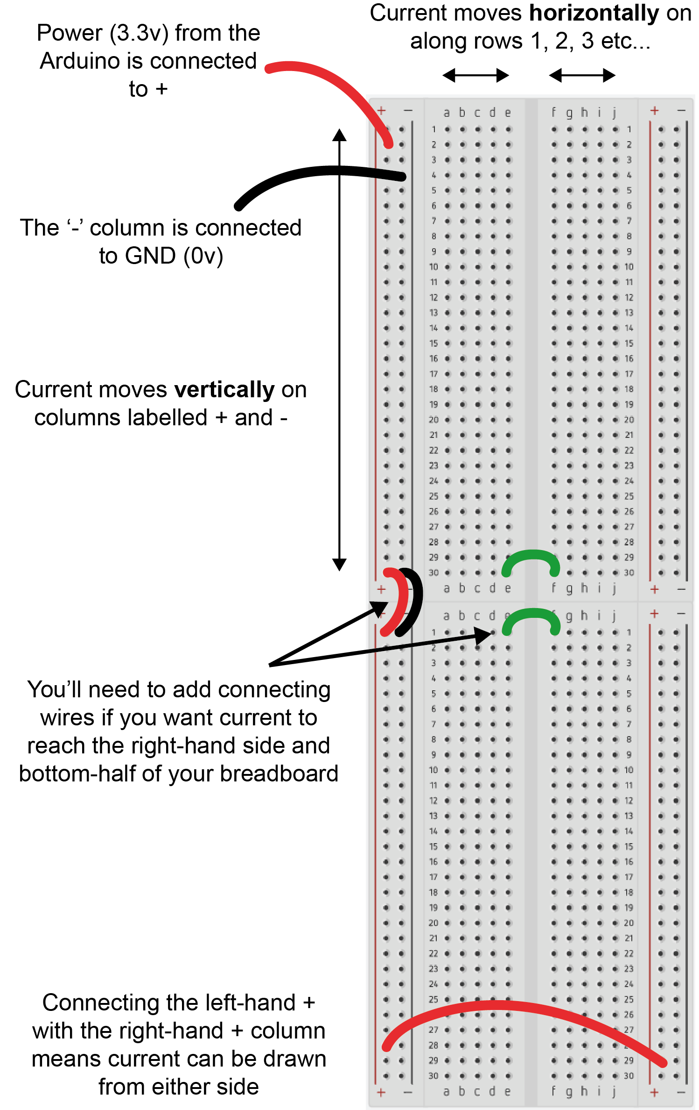

Let’s build a simple circuit with it: our light source. Use the jumper wires, 47 Ohm resistor, and LED you’ve been given to make a circuit that looks like this:[11]

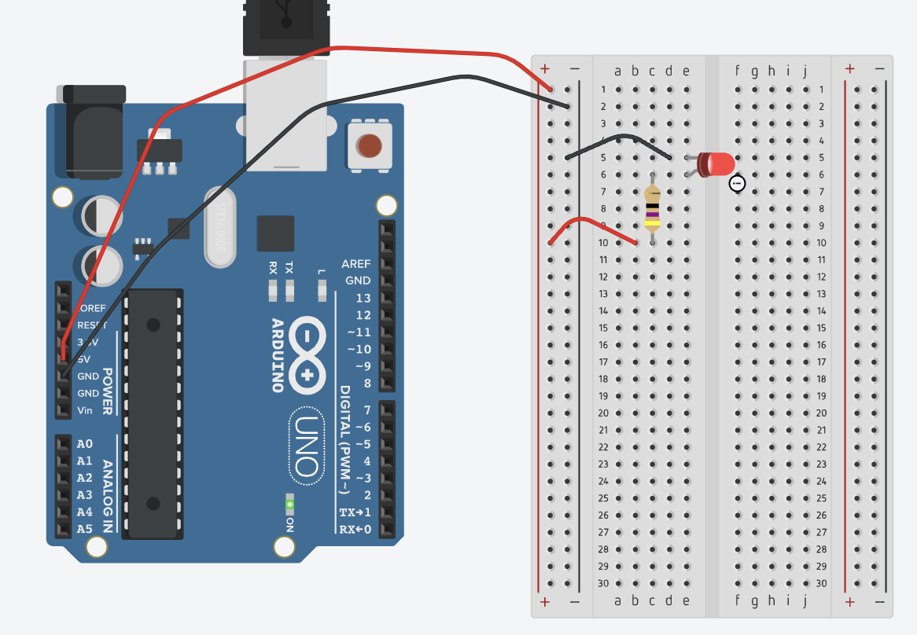

There are two important things about this circuit:

1. Make sure you’ve included the resistor or you might blow up your LED!
2. Make sure the long leg of the LED is connected to +, and the short leg is connected -, otherwise it won’t light up!

Now connect the Arduino to the USB port of your computer and the LED should light up. If it doesn’t, check the Arduino is powered on (if it is, some of its lights will be turned on) and that it’s not sat on the metal cover of your fancy laptop. Check also that you’ve plugged the long leg of the LED into “+” and the short leg of the LED into “-“.

Assuming everything’s gone well, congratulations! The 5v connection acts as a (5 volt) power source. The red[12] wire in the picture carries current into the breadboard, through the long leg of the LED, which converts the current into light. The current then flows back out the short leg of the LED, and the red wire carries it back to “GND”, which is at 0 volts.[13]

Now, all that’s left to do is put the light source on a stand so you can move it around. Get out your **LED Holder** 3D printed part. There are two sets of holes in it: a pair of big holes near the bottom, and a pair of very small holes near the top, inset in a pit that’s about the same size as the LED. Put each leg of the LED through the small holes in the LED holder. *Very carefully* connect one f-f jumper wire to each terminal of the LED and connect an m-m jumper wire to each terminal of the f-f jumper wires and plug them into your breadboard. Remember that the long leg of LED needs to be connected to “+”, and the short leg needs to be connected to “-“. When you connect your laptop to your Arduino, your LED should light up again, but it has a whole new world of freedom of movement! It’ll look something like this:

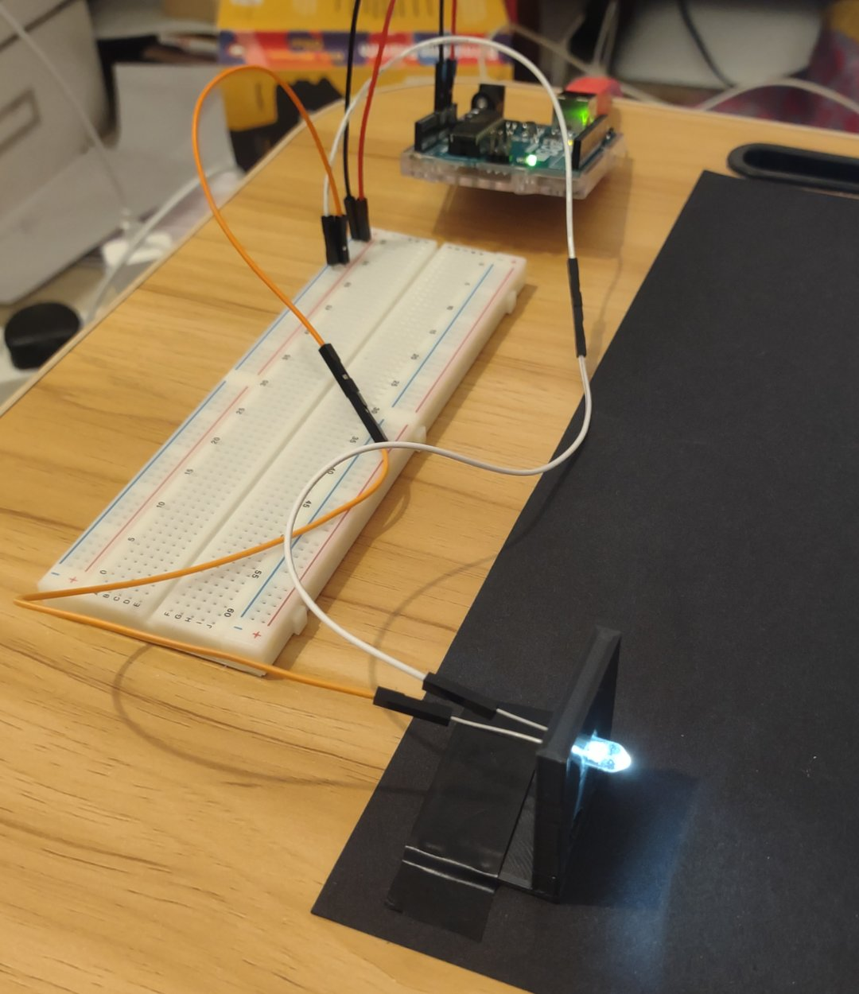

A quick final note on the LED and the value of the resistor. The resistor we’ve chosen is just “one that works” – but we can optimize *R* to achieve maximum brightness without blowing up the detector.

Now we need to join together the light source with a slit and a lens – so get the **Slit** and **Lens Holder** from your 3D printed parts. Take the 7 mm collimating lens and insert it in the lens holder.

The **LED Holder**, **Slit**, and **Lens Holder** should all neatly join together to give you something like this:

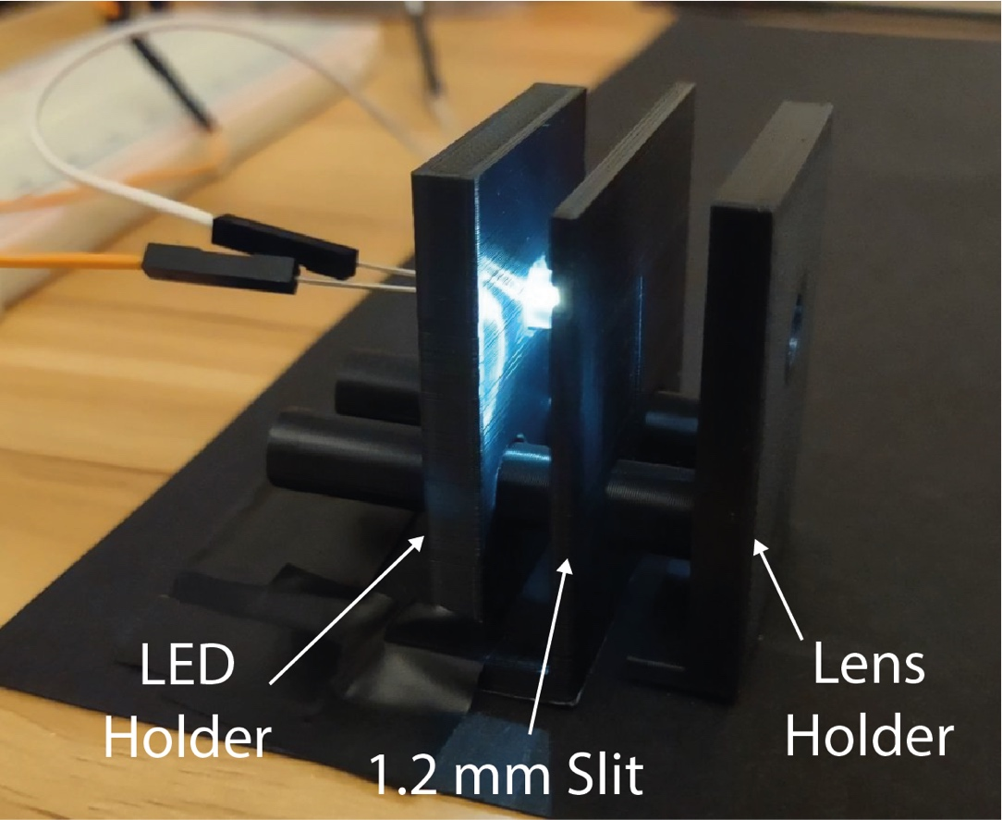

Now all that’s left is for you to bring the light into focus. Play around with the distance between the LED and the slit, and the distance between the slit and the lens, such that you produce a sharp, focused image of the slit. It should look a little like this:

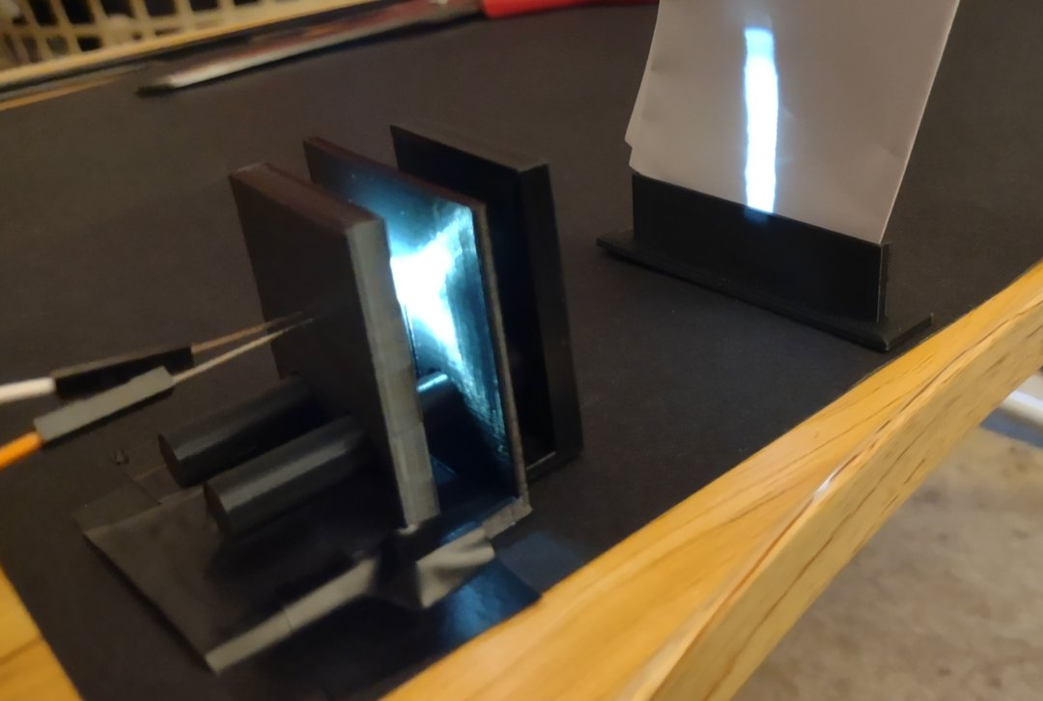

That’s it! You’ve built your light source!

# Building Your Photodetector

Our detector is a **L**ight-**D**ependent **R**esistor (LDR). Its resistance, $R_{LDR}$, changes depending on how much light lands on it. To use it, we connect it in series with a second resistor (which has a known value, $R$), and then measure the voltage drop across the LDR.[14] Build a circuit that looks like this:[15]

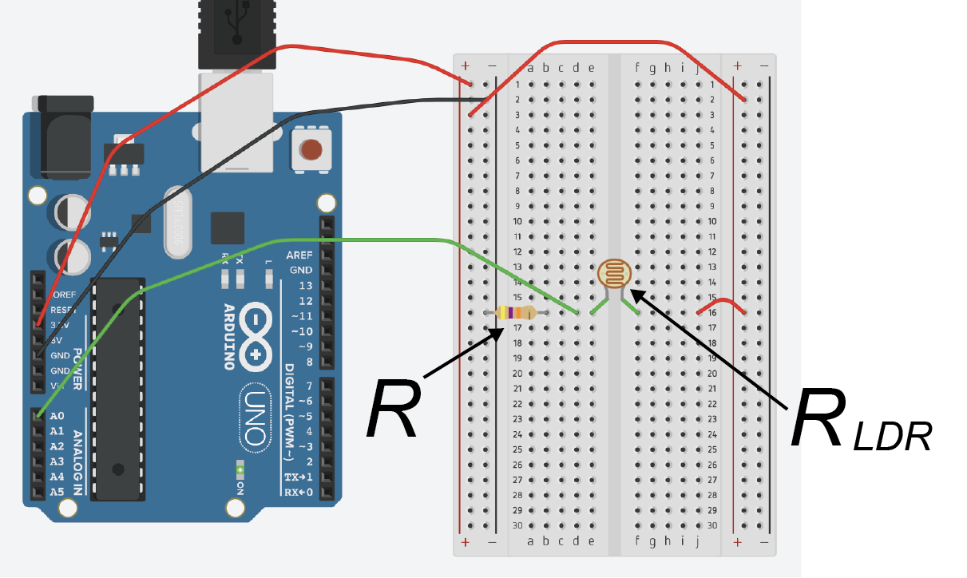

I’ve used $R=$ 47 k $Ω$ resistor for this picture – it doesn’t matter which you use, so long as it’s one of the larger ones, at least to begin with. We’re going to test them all later.

Now let’s think about what’s happening in our circuit when a light shines on it:

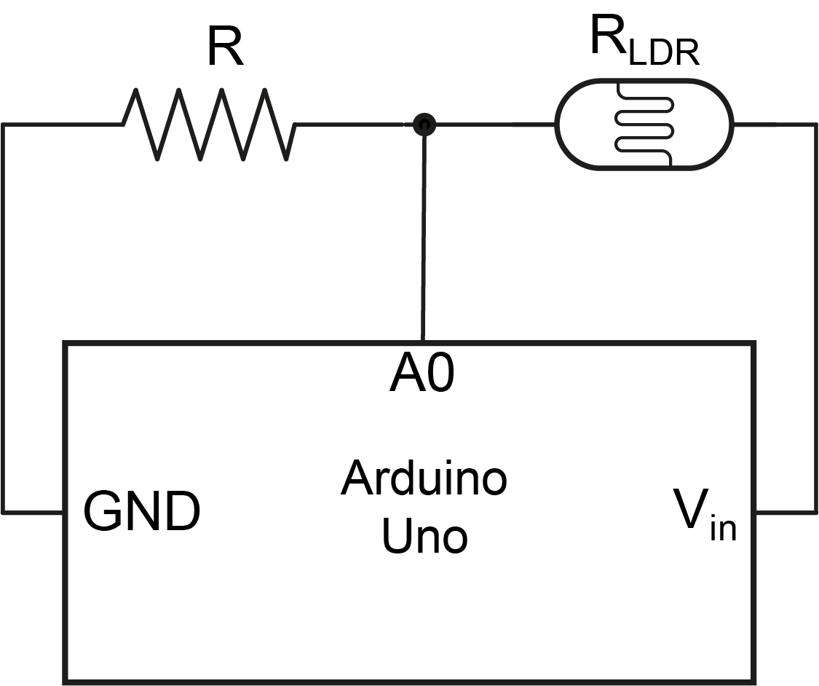

$V_{in}$ in the diagram is set by the power source – in our case 5 v. GND ('ground') is always at 0v. The voltage across this circuit must drop by 5v, where it does this is determined by the relative resistances of the LDR and the second resistor, $R_{LDR}$ and $R$ respectively. The voltage we measure on the Arduino is given by the potential divider equation:

$V_{out}=V_{in}\frac{R}{R_{LDR}+R}$ (1)

Where in this case $V_{out}$ is the voltage measured at A0 in the diagram above. When the light shines on the LDR, $R_{LDR}$ changes. When $R_{LDR}$ changes, $V_{out}$ changes, and so the signal detected by your Arduino changes.[16] What you’ll do in one of the labs is fine-tune $R$ so that the changes in $R_{LDR}$ give you the biggest possible changes in $V_{out}$, and so the best detector sensitivity.

With both the LED and the LDR circuits built, you end up with something like this:

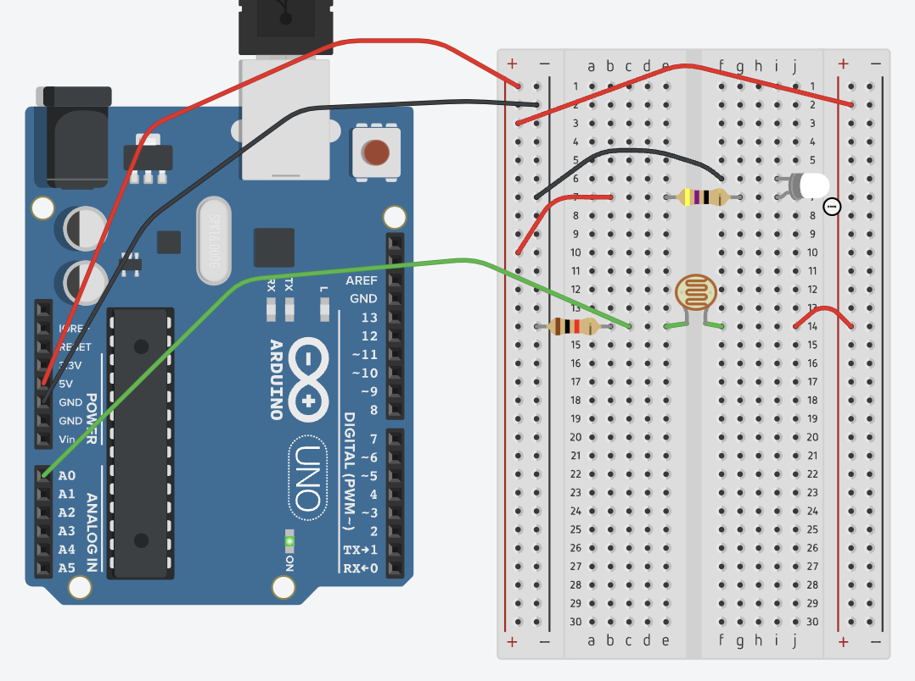

Now let’s mount our detector on a holder. Take the LDR out of the breadboard and insert it into the Detector Holder (it has two small holes for this, just like the LED).[17] Now connect it to your breadboard via some f-f and m-m jumper wires, just like you did with the LED. Note that, unlike the LED, it doesn’t matter which terminal of the LDR goes to “+” and which goes to “-“. You should get something that looks like this:

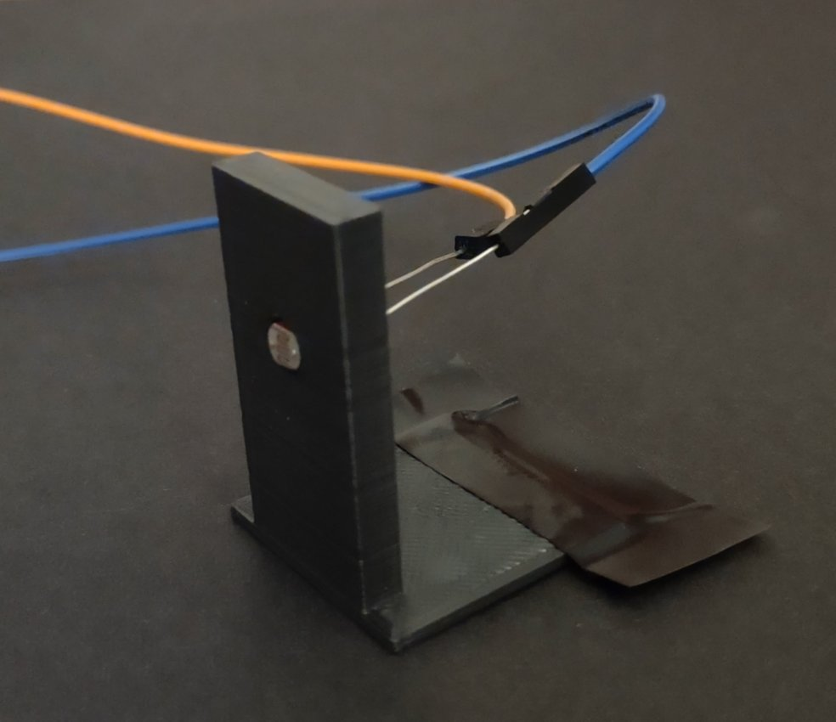

Well done, you’ve built both parts of your spectrometer – now you just have to stick it all together!

# Tidying Things Up

The last thing to do is tape things in place. Get the separation between the LED, slit, and lens just right so the slit is nicely in focus, and tape it all down on the black card. Leaving enough space for the **Cuvette Holder**, line the LDR (in its **Detector Holder**) up nicely with the focused light from the slit, and tape this in place. You should end up with something that looks like this:

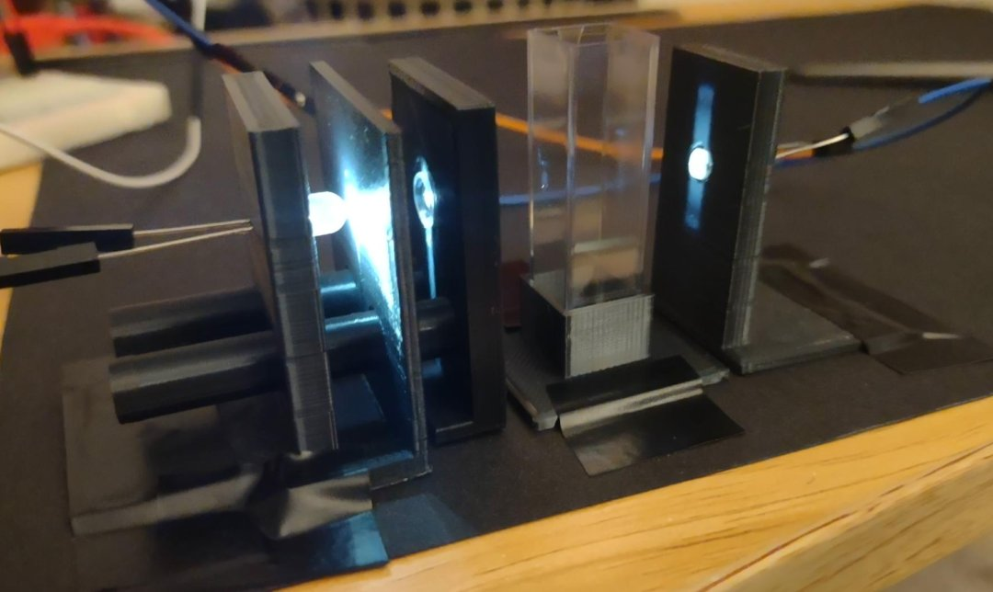

You can now modify this however you’d like. Changing the slit size, adding a diffraction grating (I’ll cover this later), and building a cover to exclude external light sources are the three most obvious modifications – but there are plenty of others!

# Reading in Data from Your Arduino

Initially, we’re going to use the Arduino software to check the output from your circuit. Open up the code “spectrometer_minimal.ino”. It should look like this:

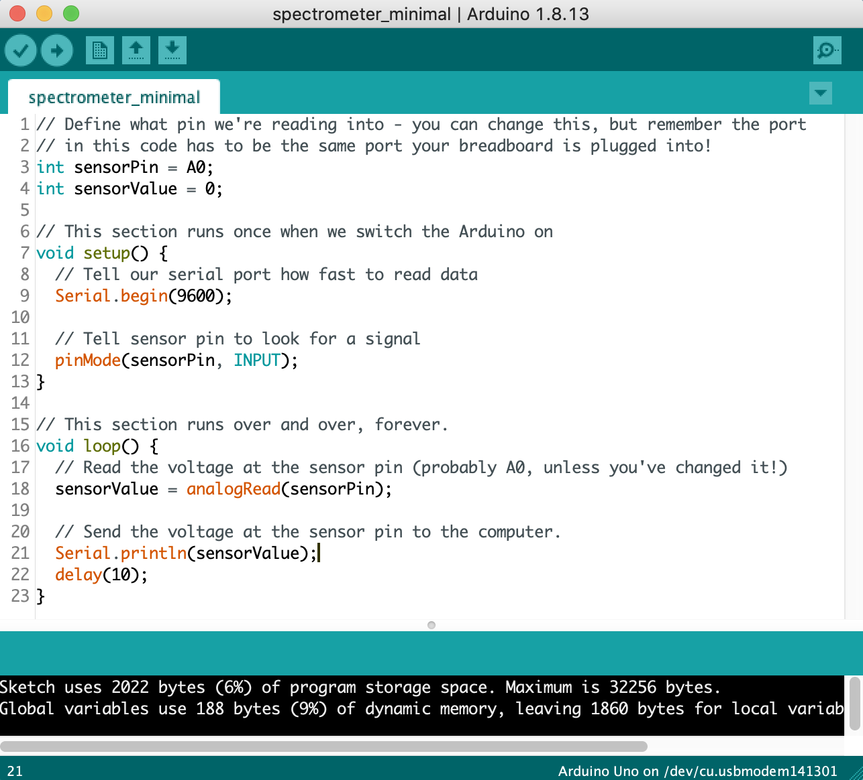

The lines starting with ‘//’ are called comments – the double-slash at the start tells the computer to ignore them. You can use these to quickly add and remove bits of code, or to add useful comments to help people understand your code (like I’ve done here!).

Now you’ve built your spectrometer, connect your Arduino to your computer, and hit “Upload” (the sideways arrow in the top-left corner). Your program should now be running on your Arduino. To check whether this is happening, go to Tools -> Serial Monitor, and you’ll get a window that shows a series of numbers, like on the bottom-right of the screen here:

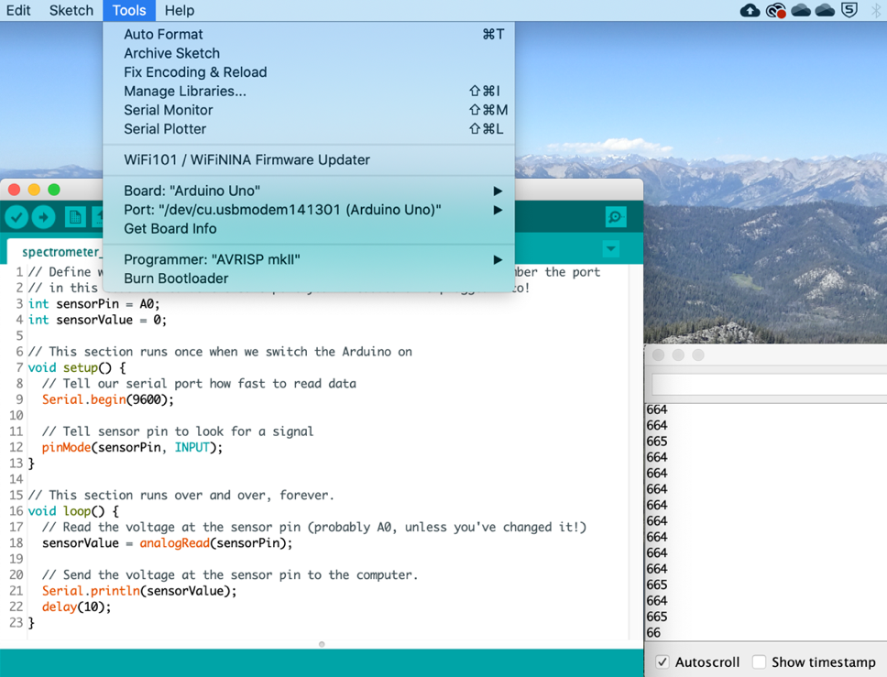

Try waving a piece of paper between the detector and the LED – you should see the numbers change.

To look at a graph of the signal from your Arduino, go to Tools -> Serial Plotter. You’ll get a window that looks like the one shown on the bottom-right corner of the screen shown below:

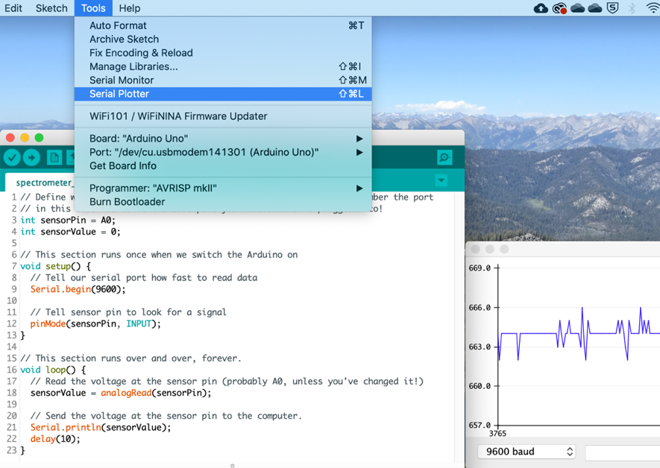

Again, wave a piece of paper between the LED and the detector, you should see the values changing. If should look like this:

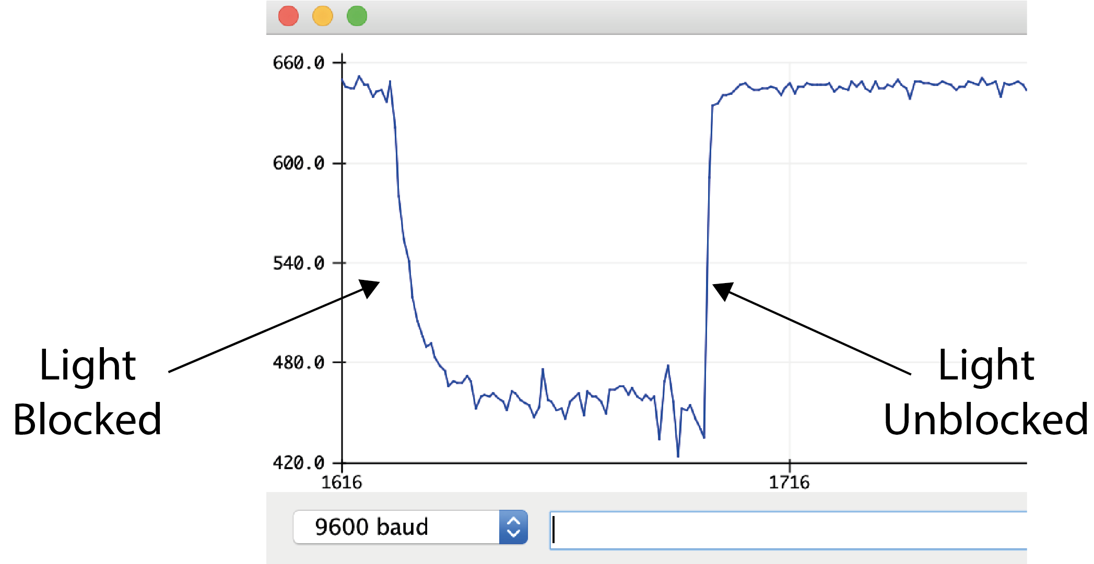

If this hasn’t worked – *have a play*. Switch things off and on. Restart your computer. Make sure everything’s plugged in. Make sure both the LED and the LDR have a circuit that runs from “+” to “-“. Try changing the resistor $R$. You can’t really break anything (apart from the LED, and they’re very cheap). If things still aren’t really working, contact a course organiser and they’ll help you out.

# Using Python to Record Data

We’re going to use Python to read and save data from your Arduino to your computer. Move the jupyter notebook ‘data_reader_mac.ipynb’ to a convenient directory (again, I’ve used ‘/Users/joe/Desktop/python’/)[18] and open it up using Anaconda Navigator.[19] You should get something that looks like this:

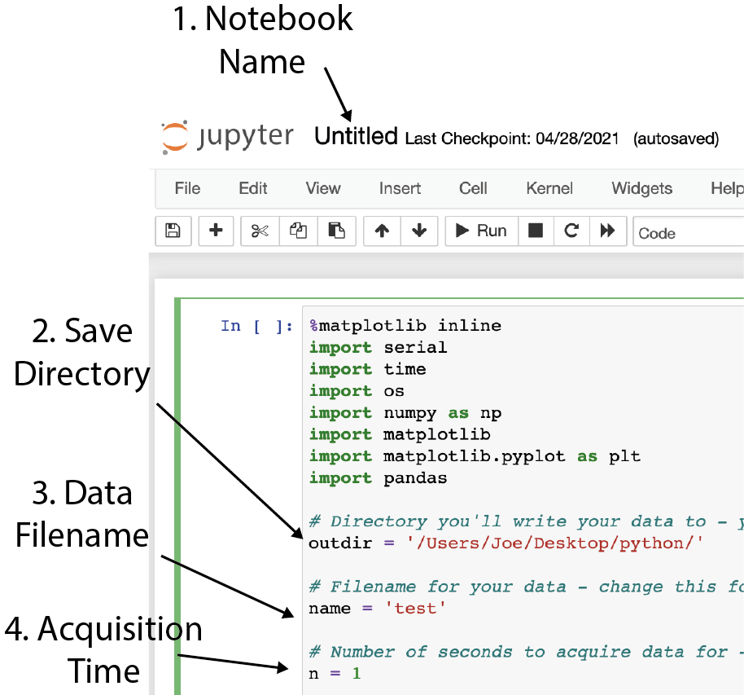

There are four important things that you should change.

1. Notebook Name

In your version this will probably say “data_reader_mac.ipynb’ – click on it if you want to change it!

1. Save Directory

Change this to something you can easily navigate to on your computer. I normally use a folder on my Desktop.

1. Data Filename

Change this so it contains data about your measurement (e.g., ‘2mM_SDS_red_filter_4s’)

1. Acquisition Time

This is the number of seconds your kit will acquire data for. The bigger this number, the better signal averaging you have, but the longer you must wait.

Note also, just like with the Arduino code, there are gray bits of code – only this time they have a “#” rather than a “//” in front of them. These are comments too! I’ve added them so you can see what each part of the code does.

Now you’re ready to acquire data on your spectrometer! Click on the box in the jupyter notebook that contains your code, and either press Shift + Enter, or click the “Run” button near the top of the window. If your Arduino is plugged in, and your Serial Plotter and Serial Monitor are closed in the Arduino software, then you should acquire data! **Please note: If Serial Monitor or Serial Plotter are open, you’ll get an error message saying “Resource Busy”. To fix this, just close the Serial Monitor/Plotter, and run the code again.** The jupyter notebook window should now look like this:

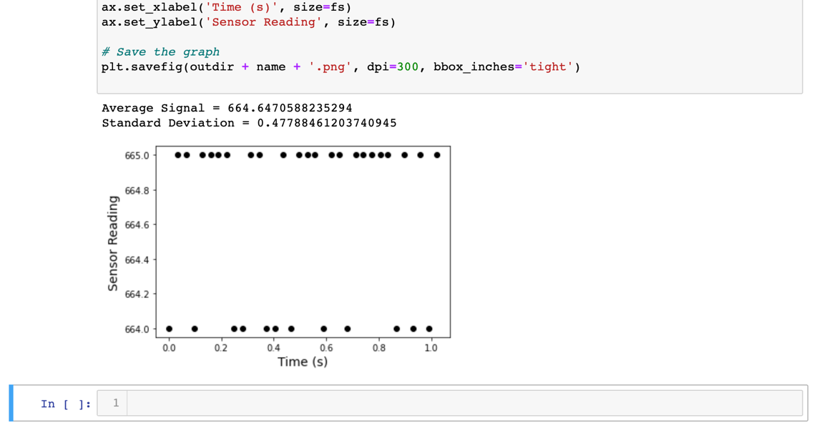

The graph shows the signal from your Arduino, $S$. This is a number between 0 (for 0 volts) and 1024 (for 5 volts). It’s currently showing 665, so around 3.25 v. In this example, the power supply is 3.3v,[20] meaning that most of the voltage drop happens along $R$, and that the resistance $R_{LDR}$ is much smaller than $R$. Try blocking the light and seeing how $S$ changes.[21] Remember to change the filename for each experiment you perform, or the data won’t save!

As well as the graph, you can see I’ve printed the average and standard deviation of the signal. You’ll find it useful to copy this to a spreadsheet for each experiment.

If you now navigate to your Save Directory (in my case ‘Users/joe/Desktop/python’), you should see two new files, in this case ‘test.csv’ and ‘test.png’:

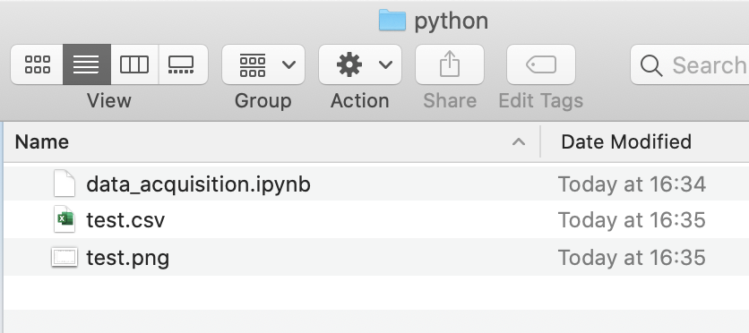

The .csv file can be opened in Excel/LibreOffice and shows the signal from your Arduino as a function of time. The .png is the graph that was plotted in jupyter notebook. If this has all gone to plan – well done! If you can’t find the files, make sure you’ve typed in the right save directory in the python script – google can help you with writing file directories. Do all the standard checks – restart your computer, unplug and plug in the Arduino, restart python / jupyter a few times. If things still don’t work – ask a demonstrator!

If you’re enjoying playing with python and Arduino, please continue to do so. You can do the analysis for the whole project in Python if you like. If you’ve found the last few hours (or days!) incredibly stressful, then you can relax! You’re done with all things code-related. You just have to press go on the code, and the rest can be done in a spreadsheet. In fact, you can even just write down the numbers from the Arduino Serial Monitor if things are going really wrong! Regardless, well done for getting this far.

# Zeroing Your Detector

You might have noticed by now that, even when the light is off, the signal from your detector *might* not be zero (if you look at Equation 1 again, you can figure out why this is!)[22]. To do this, you need to measure the signal from your detector with the lights off, $S_{zero}$. Take 3 good measures of the this and use the average as your value for $S_{zero}$. You then need to subtract this value from *all* of your measurements of $S$ when you do these experiments. The equation for absorbance is now given by:

$A= -\log_{10}{\frac{S_{sample}-S_{zero}}{S_{solvent}-S_{zero}}}$ (2)

# Adding a Diffraction Grating

Our visible light spectrometer works *fine* for our purposes without a diffraction grating. However, until we add some way of splitting the light source into its spectrum, we can’t *really* call it a spectrometer. To do this, we use a diffraction grating.

Insert your diffraction grating into your 3D printed **Grating Holder**, and place it after your cuvette holder, so that the light from the slit shines through it. Hold a piece of paper behind the grating, so that you can see the light that comes out the other side of it. At an angle of around 30˚ from the incident beam, you should see a spectrum. This is shown below, but without the pretty colours:

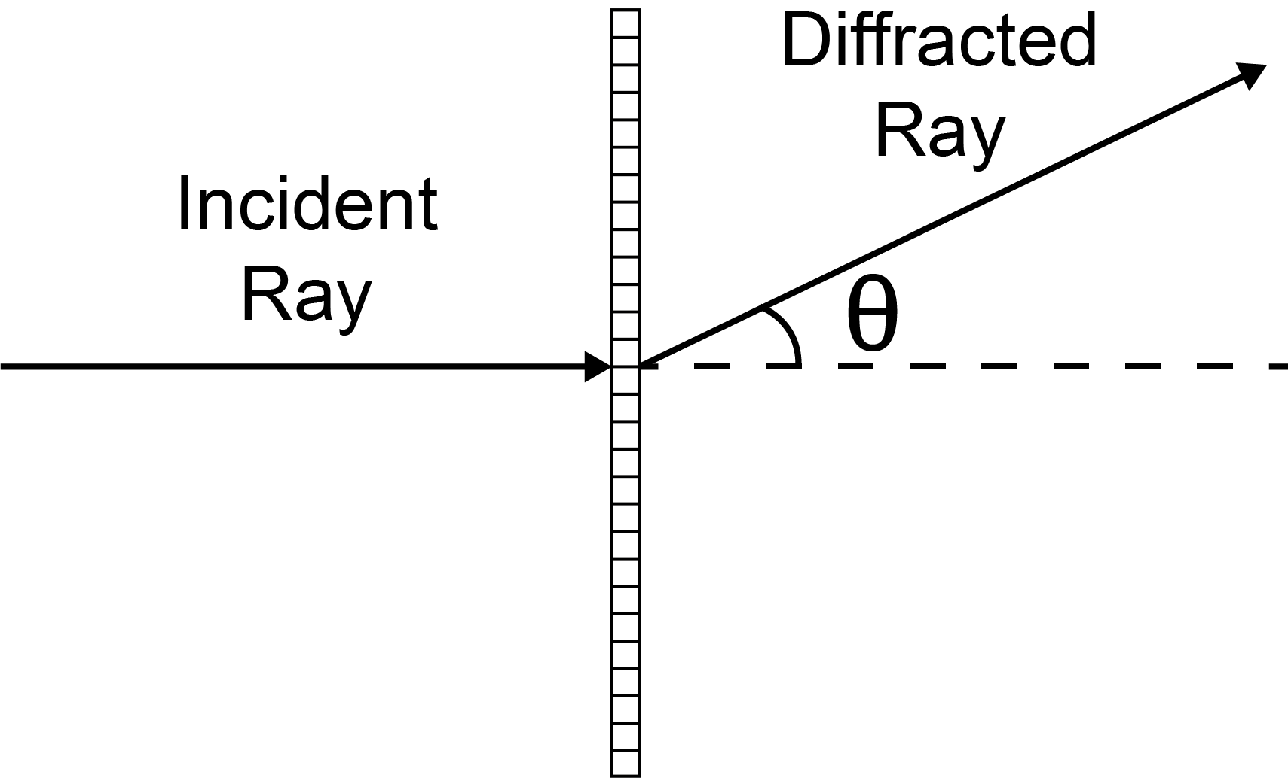

You’ll remember from 1st and 2nd year, that the relationship between the angle of the incident and the diffracted ray is given by:

$nλ=d\sin{θ}$ (3)

Where $d$ is the spacing between the lines of the grating (1 µm, for the ones you’ve been given), $λ$ is the wavelength of the light, and $n$ is the order of interference maximum (in this case, 1).

By placing your LDR at a particular angle, you can pick out the light intensity of a given wavelength. It’s now a matter of fine-tuning your system by varying slit width and distance from sample to detector, but still leaving enough signal for your detector to measure changes in intensity. Getting things just right should allow you to make fine-tuned measurements of absorbance over a fairly narrow range of wavelengths (10s of nm). A photo of the setup showing the white light spectrum of the LED is shown below – all you need to do is put the detector in the right place!

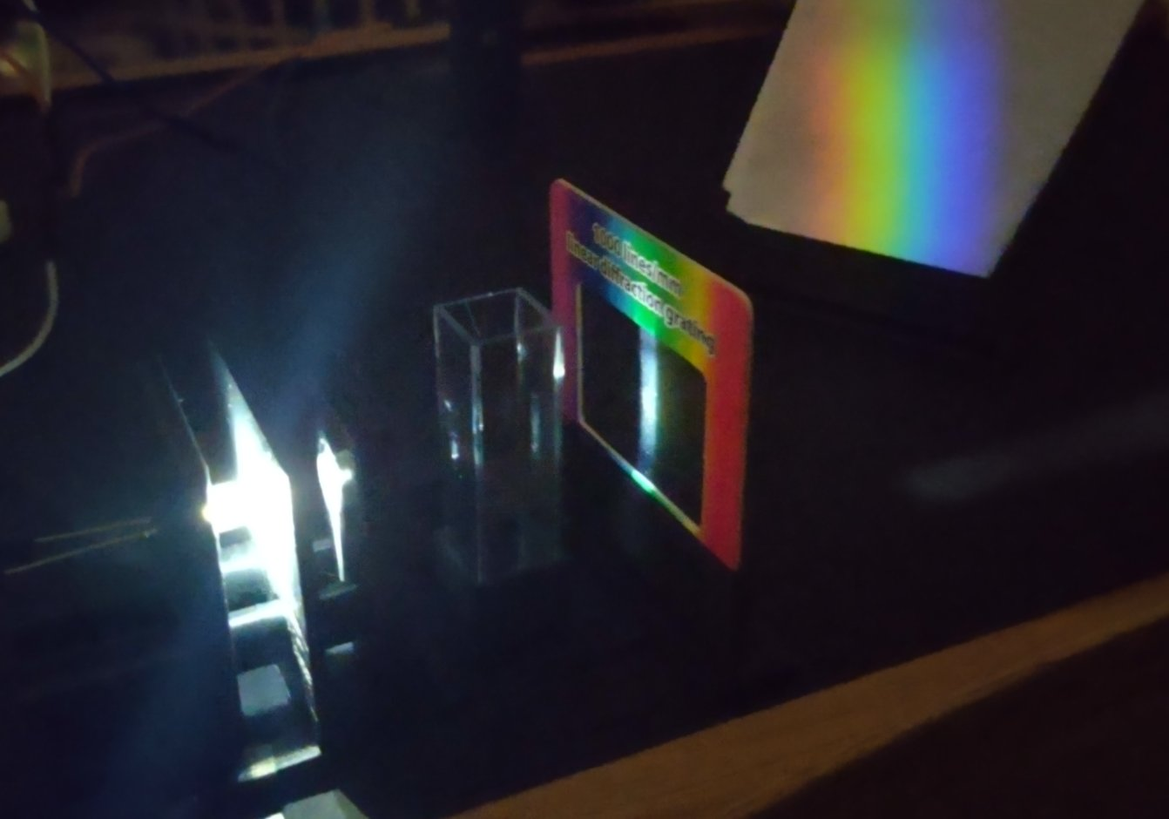

# ImageJ / FIJI

In this course, we’ll be measuring the relative size of the various fractions of our emulsions, as well the size of our droplets, using ImageJ/FIJI (FIJI stands for **F**IJI **I**s **J**ust **I**mageJ). You can download it here:

<https://imagej.net/Fiji.html#Downloads>

Despite not looking very fancy, FIJI is currently the most popular quantitative image analysis platform used by both academia and industry. It supports everything from intuitive point-and-click measurements all the way up to high-end segmentation and classification by convolutional neural networks.

To open an image, you can either go to File 🡪 Open or just drag and drop the image you’re interested in onto the box that opens when you open FIJI. When you do that, you’ll get something that looks like this fabulous photograph of an emulsion:[23]

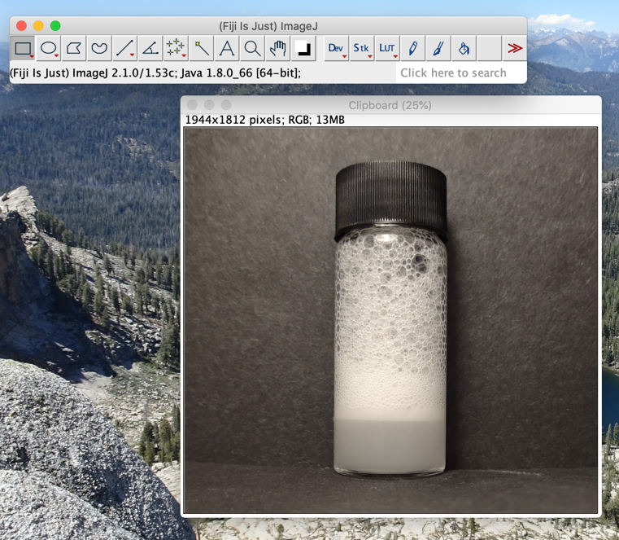

You can clearly see a big foam layer, a thin layer of oil-in-water emulsion, and a large aqueous supernatant layer at the bottom.

First, we need to set the scale. To do this, you need the size of a known object. In this case, I know the vial is 6 cm high, because I measured it beforehand. First, let’s measure the length of the vial in pixels. Click on the straight line tool and draw a line from the top to the bottom of the image. Then either press the “M” key, or go to Analyze 🡪 Measure. You should get something that looks like this:

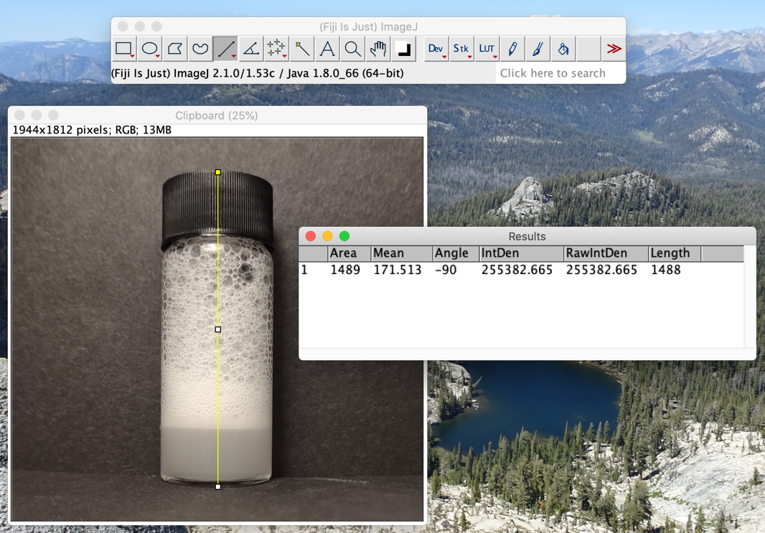

In the Results window that popped up when you pressed M, you’ll see a column titled “Length”. The number in that column is the length of your line / height of your vial in pixels (in this case, 1488 pixels). Now to set the scale, go to Analyze 🡪 Set Scale, and fill out the missing details:

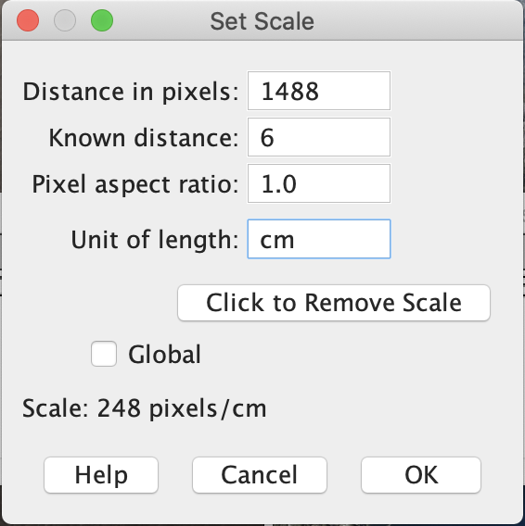

Click “OK” when you’re done. You can now measure the size of the various sections of your emulsion: let’s measure the thickness of the emulsion layer. Zoom in/out by pressing the up/down buttons on your keyboard with the mouse hovering over the image. Draw a straight line on the emulsion layer and hit M to measure it. You’ll get something that looks like this:

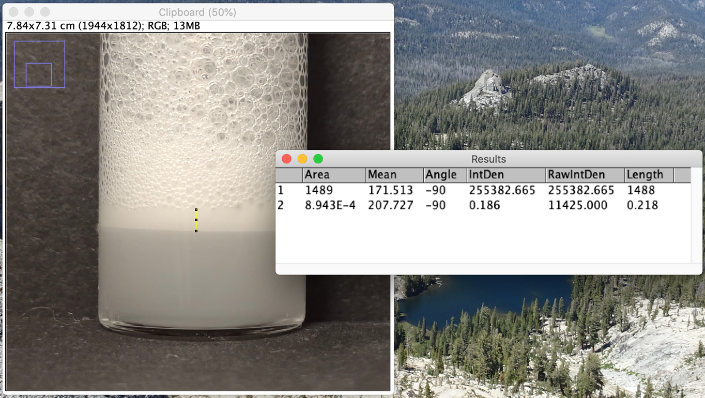

Your emulsion layer is 0.218 cm high (note that third decimal place is probably overkill).

# Image Analysis

On the simplest level, an image (as seen by a computer) is a grid of numbers with a value between 0 and 255.[24] 0 corresponds to black, 255 corresponds to white, and everything in-between corresponds to some shade of grey that gets lighter as the value increases, as shown below:

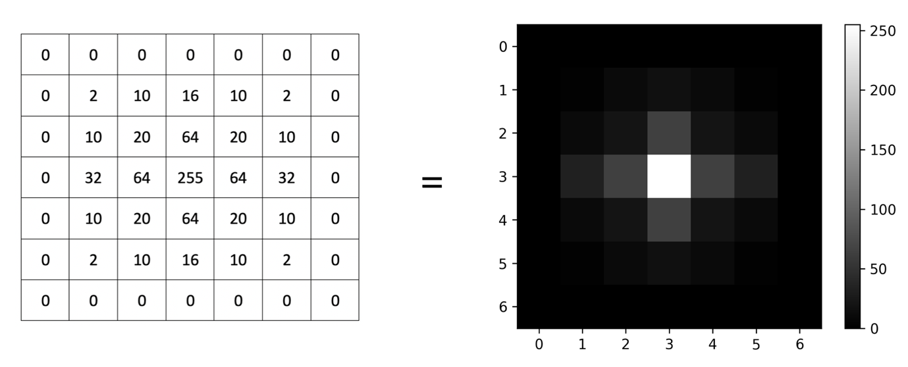

Image analysis is the discipline of applying mathematical and computational operations on this grid of numbers to extract quantitive data about the features contained in the image. FIJI/ImageJ is a really good tool for starting out in this area – it allows you to (fairly) easily apply a wide-range of pre-programmed operations, automate these operations using a script, and even do very high-end operations such as applying neural networks to the task of image analysis. Here, we’ll briefly run you through some basic operations for image analysis, and talk about how you might push things further.

Our example image is a TEM micrograph of some nanoparticles:

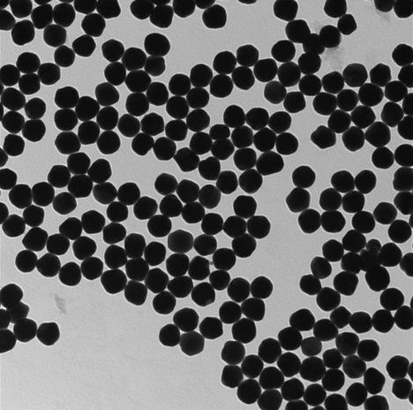

We want to measure the size of the particles in the image. One of way of doing this would be to use the method above, where we manually measure the particle diameters. However, wouldn’t it be good if we could automate this process? Well, turns out we can.

The first thing you want to do is convert it to an 8-bit, black and white image – click on Image 🡪 Type 🡪 8-bit. You should see that the text in the top-left hand corner of FIJI has changed accordingly:

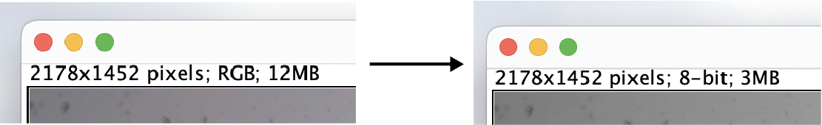

Now let’s get some information about our image. Click on the line tool, draw a line across the image, and hit “K”, the window should look something like this:

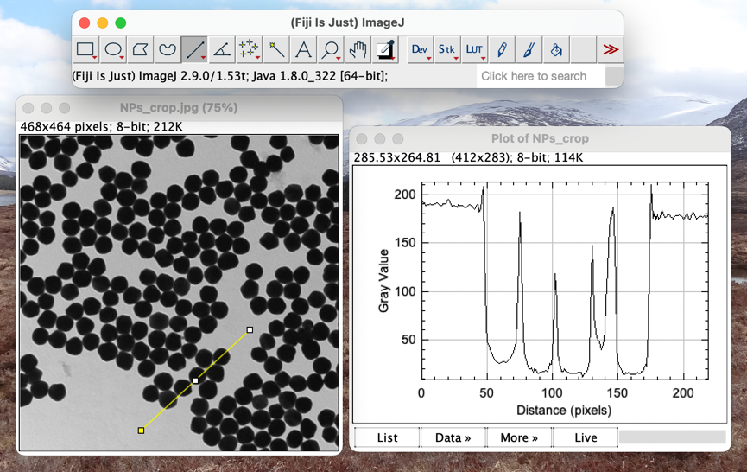

You can see dark bits in the image, corresponding to low points in the graph of gray value (like you’d expect). From the image, you also see a spatially varying background – the image is darker in the top-right corner, and lighter in the bottom-left. To remove that background, try Process 🡪 Subtract Background. Click “Preview” and tune the “rolling ball radius” so that you’re not removing important details from your particles. You should get something that looks like this:

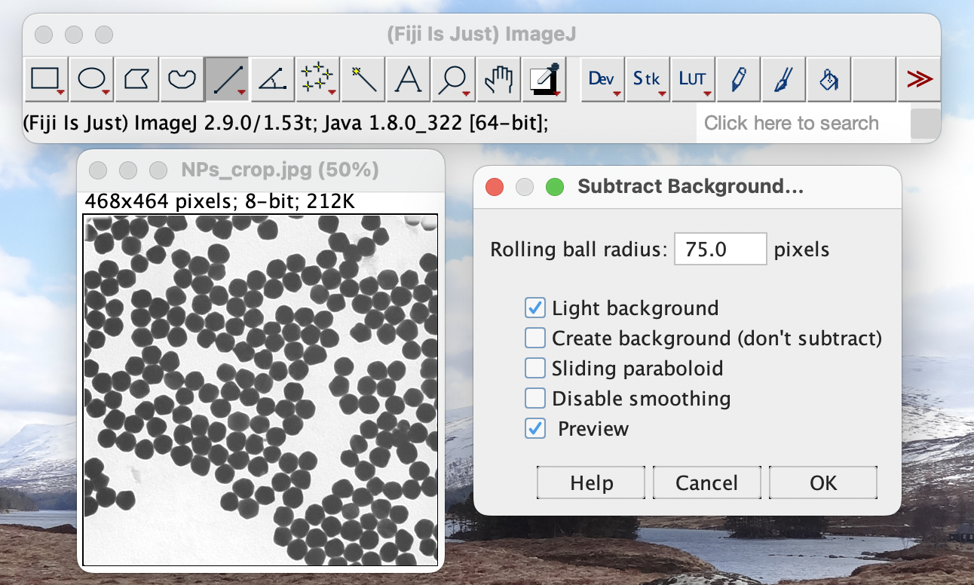

This may not have improved your image *aesthetically*, but you can imagine it’s going to make it easier to *analyse*.

Now, we need a way of separating the bits of the image we’re interested in from the background. This is called “image segmentation”. Here, we’ll use a simple segmentation technique called thresholding. Go to Image 🡪 Adjust 🡪 Threshold… - you’ll see that the image is now separated into foreground (red) and background. Adjust the sliders, or play with the drop-down list showing different methods, until you’re happy that the particles are in the foreground, and hit “Apply”:

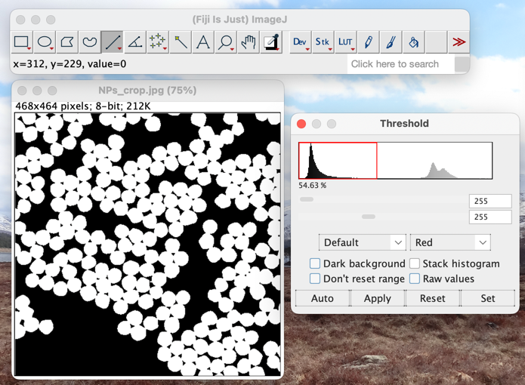

This looks good – you’ve got the particles all identified, but the problem is they all overlap each other. The solution to this is to use a technique called watershedding. To do this, go to Process 🡪 Binary 🡪 Watershed:

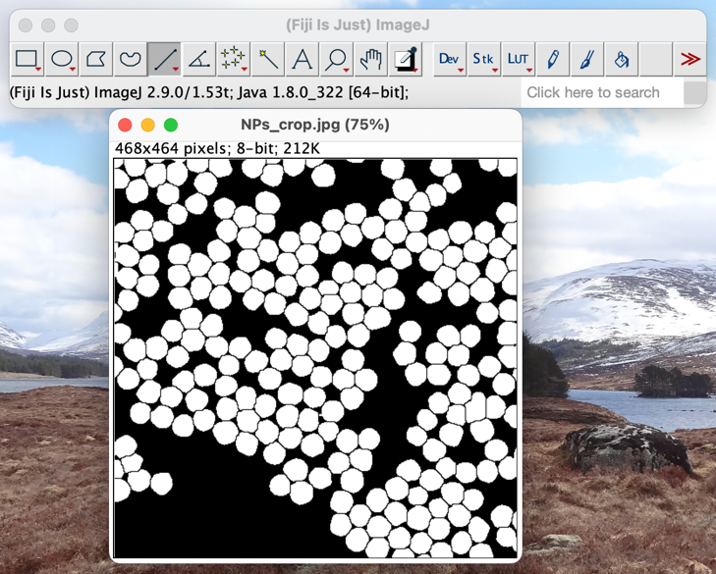

There are now lines drawn between the particles – we can analyse them! To do this, go to Analyze 🡪 Analyze Particles…

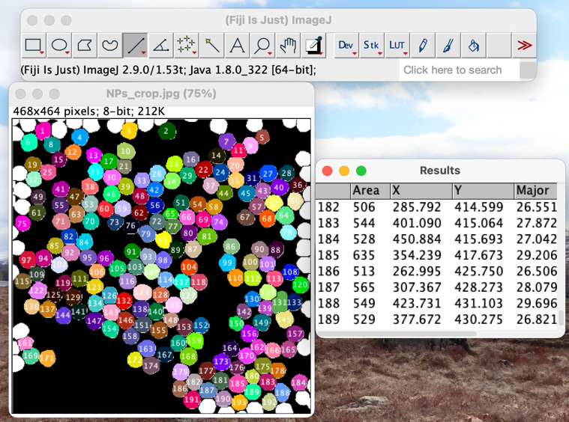

Your image should now be covered with coloured particles, and you should have a list of “Results” that you can copy into Excel.

Now – the sample you’re studying is a little different. In the above example, we were looking at solid objects, but emulsions are tricky. They consist of an inside and an outside that are light, and edges that are dark. There are lots of ways you can approach that problem, but you might find the following link useful:

<https://imagej.net/plugins/hough-circle-transform>

## Automating Things a Bit More

You’ll have noticed that clicking all those buttons is quite laborious. Thankfully, FIJI has a very good macro language that allows you to automate all the above steps. To see how it works, go to Plugins 🡪 Macros 🡪 Record…. Now repeat the above steps on your image. You’ll something that looks like this:

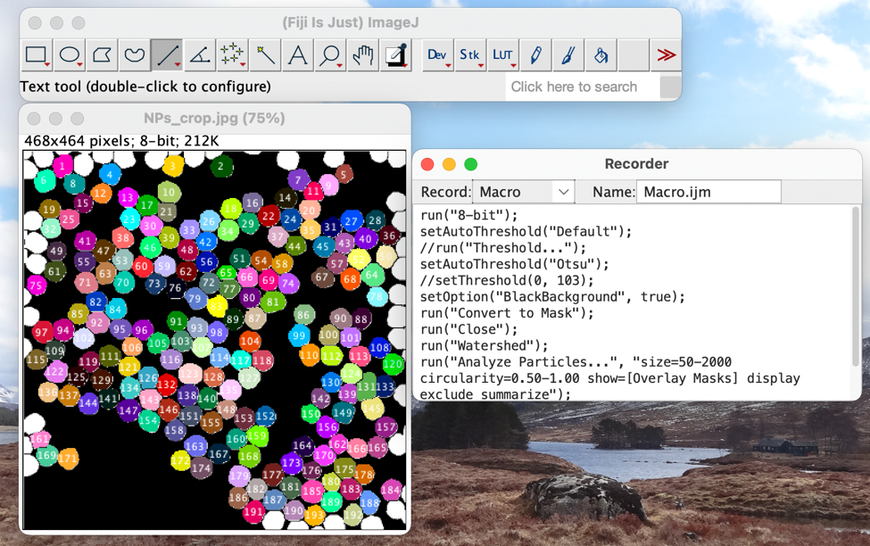

You can take the recorded macro and copy the text into the macro player at Plugins 🡪 Macros 🡪 New 🡪 Macro. Paste the recorded macro into the box, open up a new image, and click “Run”. You’ll see that the macro applies all the operations you were doing by hand without all that pesky clicking. You might find you need to delete or modify some lines, but this is all part of the fun.

Note that this is the start of writing macros. You can, for example, modify your macro to run on multiple open images by writing a for loop. For full documentation of the potential of macros in FIJI, take a look at the following links:

<https://imagej.nih.gov/ij/developer/macro/macros.html>

<https://imagej.nih.gov/ij/docs/macro_reference_guide.pdf>

<https://bridges.monash.edu/articles/educational_resource/Fiji_Training_Manual_v6_5_/21901989>

You’ll also find lots of helpful documentation on google.[25] Happy hacking!

1. You can find a useful chart for looking up and calculating the resistance of resistors here: <https://www.eeweb.com/tools/5-band-resistor-calculator/>.
2. If you’re colour blind, resistors can be hard to distinguish. I can’t *currently* think of a way round this, so please do ask and I’ll happily (and speedily) help here.
3. In Windows it would be: ‘C:/Users/joe/Desktop/python/’ – note that Python likes forward slashes in its directories, even if Windows prefers backslashes.
4. This is, for many of you, likely to be the trickiest and newest part of the practical. Please ask a demonstrator if you’re having problems!
5. You can also use your own Python installation – if you’re doing that, you’ll need to install the modules *matplotlib, numpy, and pyserial*.
6. These are bits of code that other people have written for us, so we don’t have to.
7. In Windows it would be: ‘C:\Users\joe\Desktop\python’
8. I believe you now also qualify for an MS in data science.
9. In Windows it will look more like: “COM4 (Arduino Uno)”
10. Just as all computer problems can fixed by restarting things, most electronics things can be fixed by turning the diodes around. Try this before you ask for help!
11. If you’re having trouble inserting wires into the breadboard, loosen it up by pushing a jumper wire in and out a few times.
12. It doesn’t matter if the wire you’ve used in pink, blue, purple, or anything else. They’re all the same in your kit.
13. You might remember – the actual *electrons* are moving the other way.
14. A conceptually important thing to realise here – the Arduino is just a fancy voltmeter. Actually, *almost all modern scientific instruments are just fancy voltmeters.*
15. I’ve not drawn the LED circuit for simplicity – obviously, that should be on your breadboard too!
16. One of the analysis problems is to figure out *how* it changes.
17. Avoid using glue or blu-tak or anything to hold the detector in place – these can mess up the resistance of the LDR!
18. C:Users/joe/Desktop/python in Windows! Note that we use forward slashes in Python, rather than the normal ‘\’ that you typically see in Windows.
19. You can run the script directly from a terminal too, if you want. Though you’ll want to edit some of the matplotlib parts, which are written for jupyter notebook.
20. Though in the labs you should use the 5v circuit!
21. Ideally, think about the potential divider equation while you’re doing it.
22. Note – even with zero detector noise and in a perfectly dark room, the zero signal *still* wouldn’t be zero! Think about why this might be, possibly while looking at equation 1.
23. Backlit, black background, and not from an angle
24. This for the case of an 8-bit image, where each pixel contains an 8-bit number which is between 00000000 (0, in decimal) and 11111111 (255, in decimal). You can have 16-bit, and 32-bit images (and more!) which have a wider range of values.
25. You’re possibly thinking that this is the exact opposite of what you’re often told to do, and often there’s good reason for that – how do you test whether a statement is true or not? But here’s the thing about coding – you *really can test* whether or not a piece of code is doing what you think it’s doing. If you just blindly copy a piece of code down from the internet and run it, it will probably give you nonsense. But, if you put in the work to test whether the output of a piece of code is sensible and understand what the code is doing, then taking it from unconventional sources is totally acceptable!